Retail Marketing Campaign Analytics
A retail company wants to analyze customer buying behavior and marketing campaign performance using Snowflake sample data.
The company has three teams:
1. Marketing Analysts
2. Finance Team
3. ETL Developers
Each team should use a separate warehouse. The company also wants to improve query performance using:
1. Warehouse scaling
2. Query result cache
3. Cluster key on customer sales date
Use Snowflake sample data from:
SNOWFLAKE_SAMPLE_DATA.TPCDS_SF10TCL.STORE_SALES
SNOWFLAKE_SAMPLE_DATA.TPCDS_SF10TCL.CUSTOMER
SNOWFLAKE_SAMPLE_DATA.TPCDS_SF10TCL.DATE_DIM
SNOWFLAKE_SAMPLE_DATA.TPCDS_SF10TCL.ITEM
________________________________________
Questions
Part 1: Warehouse Setup
Create three warehouses:
1. MARKETING_WH for marketing analysts
2. FINANCE_WH for finance team
3. ETL_WH for ETL developers
Use different warehouse sizes based on workload.
Ans:
CREATE OR REPLACE WAREHOUSE MARKETING_WH
WITH
WAREHOUSE_SIZE = 'XSMALL'
AUTO_SUSPEND = 60
AUTO_RESUME = TRUE
INITIALLY_SUSPENDED = TRUE;

CREATE OR REPLACE WAREHOUSE FINANCE_WH
WITH
WAREHOUSE_SIZE = 'SMALL'
AUTO_SUSPEND = 60
AUTO_RESUME = TRUE
INITIALLY_SUSPENDED = TRUE;

CREATE OR REPLACE WAREHOUSE ETL_WH
WITH
WAREHOUSE_SIZE = 'MEDIUM'
AUTO_SUSPEND = 60
AUTO_RESUME = TRUE
INITIALLY_SUSPENDED = TRUE;
Output:
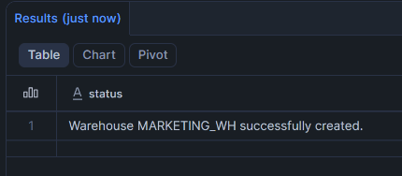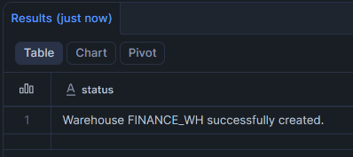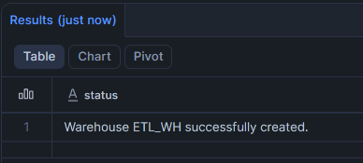
________________________________________
Part 2: Role Setup
Create three roles:
1. MARKETING_ANALYST
2. FINANCE_USER
3. ETL_DEVELOPER
Grant each role access only to its assigned warehouse.
Ans:
CREATE OR REPLACE ROLE MARKETING_ANALYST;
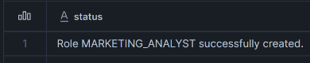
CREATE OR REPLACE ROLE FINANCE_USER;
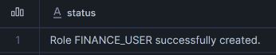
CREATE OR REPLACE ROLE ETL_DEVELOPER;
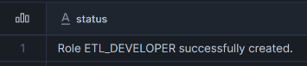
GRANT USAGE ON WAREHOUSE MARKETING_WH
TO ROLE MARKETING_ANALYST;

GRANT USAGE ON WAREHOUSE FINANCE_WH
TO ROLE FINANCE_USER;

GRANT USAGE ON WAREHOUSE ETL_WH
TO ROLE ETL_DEVELOPER;
Output:
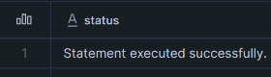
________________________________________
Part 3: User Setup
Create users:
1. MKT_USER1
2. FIN_USER1
3. ETL_USER1
Set default role and default warehouse for each user.
Ans:
CREATE OR REPLACE USER MKT_USER1
PASSWORD = 'Marketing@123'
DEFAULT_ROLE = MARKETING_ANALYST
DEFAULT_WAREHOUSE = MARKETING_WH
MUST_CHANGE_PASSWORD = FALSE;
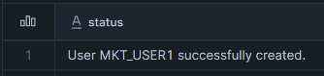
CREATE OR REPLACE USER FIN_USER1
PASSWORD = 'Finance@123'
DEFAULT_ROLE = FINANCE_USER
DEFAULT_WAREHOUSE = FINANCE_WH
MUST_CHANGE_PASSWORD = FALSE;
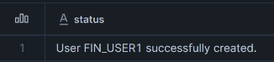
CREATE OR REPLACE USER ETL_USER1
PASSWORD = 'ETL@123'
DEFAULT_ROLE = ETL_DEVELOPER
DEFAULT_WAREHOUSE = ETL_WH
MUST_CHANGE_PASSWORD = FALSE;
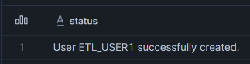
GRANT ROLE MARKETING_ANALYST TO USER MKT_USER1;

GRANT ROLE FINANCE_USER TO USER FIN_USER1;

GRANT ROLE ETL_DEVELOPER TO USER ETL_USER1;
Output:
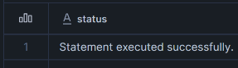
________________________________________
Part 4: Create Performance Demo Database
Create a database called:
RETAIL_MARKETING_DB
Create a table called:
CAMPAIGN_SALES
using Snowflake sample tables.
Ans:
CREATE OR REPLACE DATABASE RETAIL_MARKETING_DB;
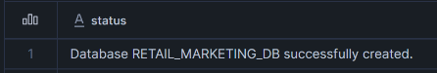
USE DATABASE RETAIL_MARKETING_DB;
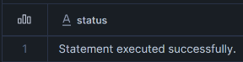
USE SCHEMA PUBLIC;

CREATE OR REPLACE TABLE CAMPAIGN_SALES AS
SELECT
SS.SS_SOLD_DATE_SK,
D.D_DATE AS SALE_DATE,
SS.SS_CUSTOMER_SK,
C.C_FIRST_NAME,
C.C_LAST_NAME,
SS.SS_ITEM_SK,
I.I_ITEM_DESC,
I.I_CATEGORY,
SS.SS_QUANTITY,
SS.SS_SALES_PRICE,
SS.SS_NET_PROFIT
FROM SNOWFLAKE_SAMPLE_DATA.TPCDS_SF10TCL.STORE_SALES SS
JOIN SNOWFLAKE_SAMPLE_DATA.TPCDS_SF10TCL.CUSTOMER C
ON SS.SS_CUSTOMER_SK = C.C_CUSTOMER_SK
JOIN SNOWFLAKE_SAMPLE_DATA.TPCDS_SF10TCL.DATE_DIM D
ON SS.SS_SOLD_DATE_SK = D.D_DATE_SK
JOIN SNOWFLAKE_SAMPLE_DATA.TPCDS_SF10TCL.ITEM I
ON SS.SS_ITEM_SK = I.I_ITEM_SK
LIMIT 500000000;
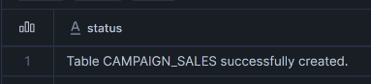
SELECT * FROM CAMPAIGN_SALES;
Output:
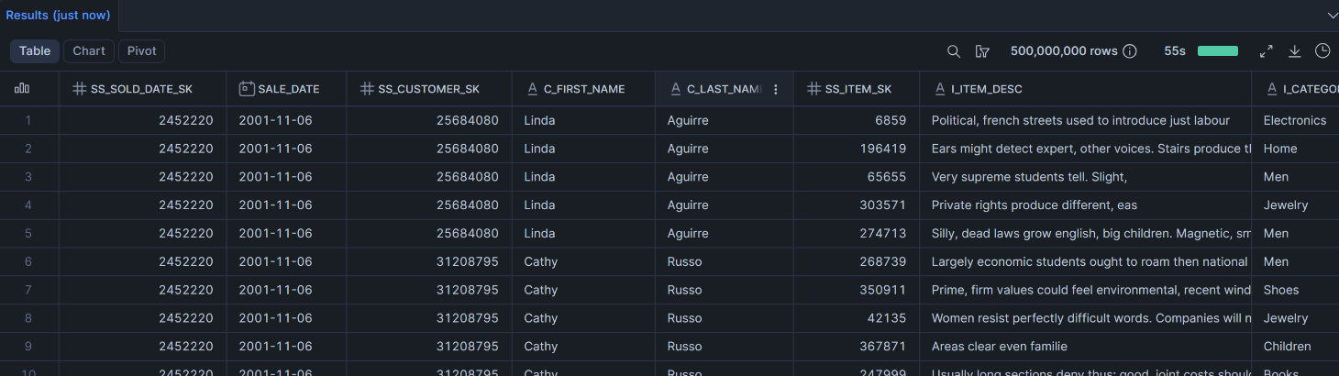
________________________________________
Part 5: Grant Permissions
Grant proper database, schema, and table permissions to each role.
Marketing and Finance can only read data.
ETL Developer can create and modify tables.
Ans:
1)Grant proper database, schema, and table permissions to each role.
GRANT USAGE ON DATABASE RETAIL_MARKETING_DB
TO ROLE MARKETING_ANALYST;

GRANT USAGE ON DATABASE RETAIL_MARKETING_DB
TO ROLE FINANCE_USER;

GRANT USAGE ON DATABASE RETAIL_MARKETING_DB
TO ROLE ETL_DEVELOPER;

GRANT USAGE ON SCHEMA RETAIL_MARKETING_DB.PUBLIC
TO ROLE MARKETING_ANALYST;

GRANT USAGE ON SCHEMA RETAIL_MARKETING_DB.PUBLIC
TO ROLE FINANCE_USER;

GRANT USAGE ON SCHEMA RETAIL_MARKETING_DB.PUBLIC
TO ROLE ETL_DEVELOPER;
2)Marketing and Finance can only read data.
GRANT SELECT ON TABLE RETAIL_MARKETING_DB.PUBLIC.CAMPAIGN_SALES
TO ROLE MARKETING_ANALYST;

GRANT SELECT ON TABLE RETAIL_MARKETING_DB.PUBLIC.CAMPAIGN_SALES
TO ROLE FINANCE_USER;
3)ETL Developer can create and modify tables.
GRANT ALL PRIVILEGES ON TABLE RETAIL_MARKETING_DB.PUBLIC.CAMPAIGN_SALES
TO ROLE ETL_DEVELOPER;
Output:
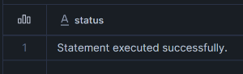
________________________________________
Part 6: Performance Testing
Run a sales analysis query using XSMALL warehouse.
Then scale up the warehouse to SMALL.
Compare performance.
Then scale it down again.
Ans:
ALTER WAREHOUSE MARKETING_WH
SET WAREHOUSE_SIZE = 'XSMALL';
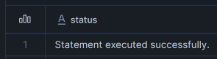
RUN THE QUERY AND CHECK EXECUTION TIME:
SELECT
I_CATEGORY,
SUM(SS_SALES_PRICE) AS TOTAL_SALES,
SUM(SS_NET_PROFIT) AS TOTAL_PROFIT
FROM CAMPAIGN_SALES
GROUP BY I_CATEGORY
ORDER BY TOTAL_SALES DESC;
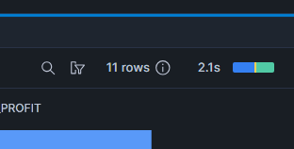
SCALE DOWN THE WAREHOUSE TO OPTIMIZE THE EXECUTION TIME:
ALTER WAREHOUSE MARKETING_WH
SET WAREHOUSE_SIZE = 'SMALL';


RUN THE SAME QUERY AGAIN TO CHECK IF THE EXECUTION TIME IS REDUCED:
SELECT
I_CATEGORY,
SUM(SS_SALES_PRICE) AS TOTAL_SALES,
SUM(SS_NET_PROFIT) AS TOTAL_PROFIT
FROM CAMPAIGN_SALES
GROUP BY I_CATEGORY
ORDER BY TOTAL_SALES DESC;
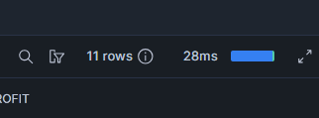
NOW SCALE UP THE WAREHOUSE:
ALTER WAREHOUSE MARKETING_WH
SET WAREHOUSE_SIZE = 'XSMALL';

________________________________________
Part 7: Cache Testing
Run the same query twice.
Observe why the second query is faster.
Ans:
RUN THE QUERY AND CHECK QUERY PROFILE TO RECORD EXECUTION TIME:
SELECT
I_CATEGORY,
COUNT(*) AS TOTAL_ORDERS
FROM CAMPAIGN_SALES
GROUP BY I_CATEGORY;
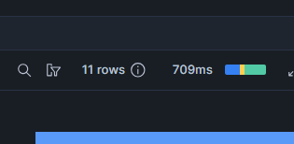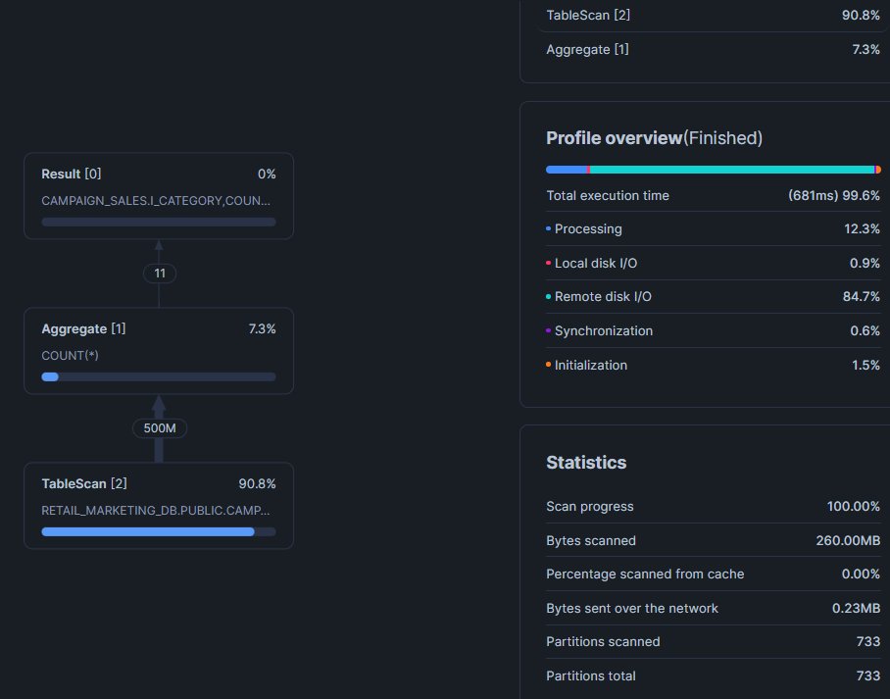
NOW RUN THE SAME QUERY AGAIN TO CHECK THE REDUCED EXECUTION TIME AND CACHE USE(WHICH MEANS THE PREVIOUS RESULT IS USED):
SELECT
I_CATEGORY,
COUNT(*) AS TOTAL_ORDERS
FROM CAMPAIGN_SALES
GROUP BY I_CATEGORY;
Output:
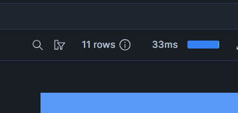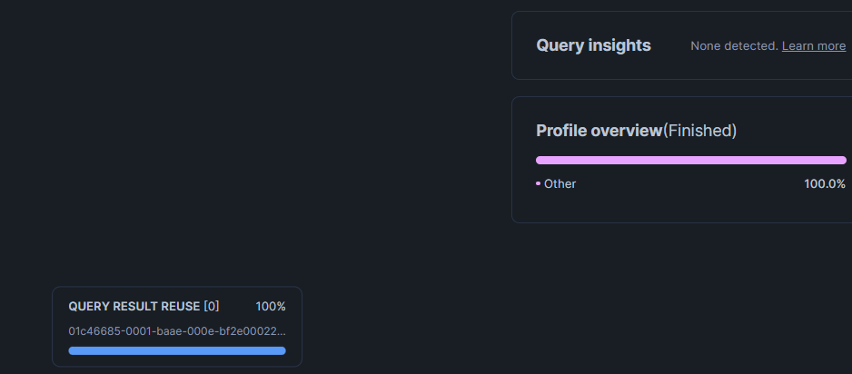
________________________________________
Part 8: Cluster Key Testing
Run a date-filter query before clustering.
Add cluster key on SALE_DATE.
Run the same query again.
Compare performance.
Ans:
RUN THE QUERY TO RECORD EXECUTION TIME AND PARTITIONS SCANNED:
SELECT
SALE_DATE,
SUM(SS_SALES_PRICE) AS SALES
FROM CAMPAIGN_SALES
GROUP BY SALE_DATE
ORDER BY SALE_DATE;
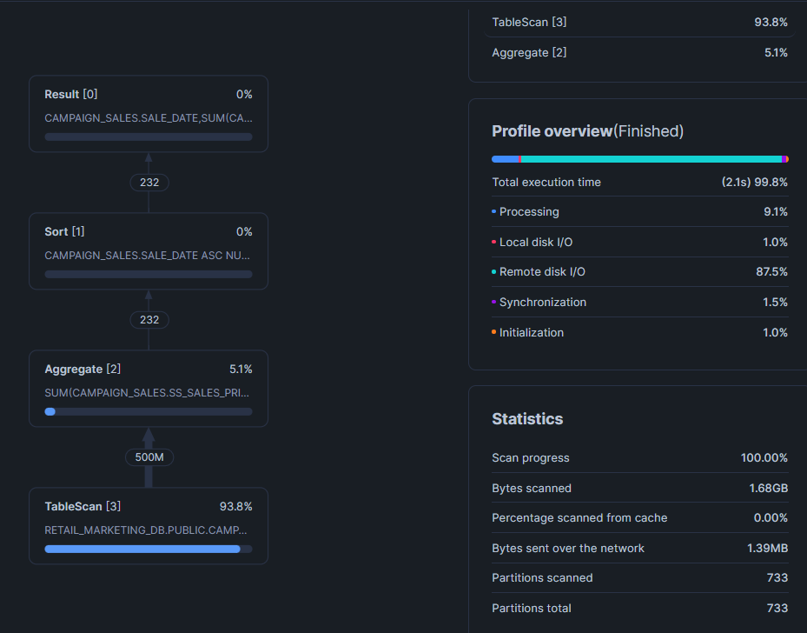
NOW ADD A CLUSTER KEY TO PRUNE AND REDUCE THE NUMBER OF PARTITIONS TO BE SCANNED:
ALTER TABLE CAMPAIGN_SALES
CLUSTER BY (SALE_DATE);



NOW RUN THE SAME QUERY AGAIN AND RECORD THE PARTITIONS:
SELECT
SALE_DATE,
SUM(SS_SALES_PRICE) AS SALES
FROM CAMPAIGN_SALES
GROUP BY SALE_DATE
ORDER BY SALE_DATE;
Output:
